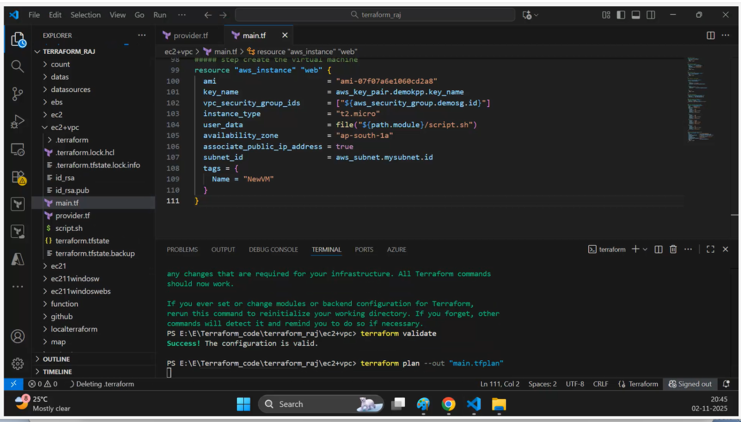

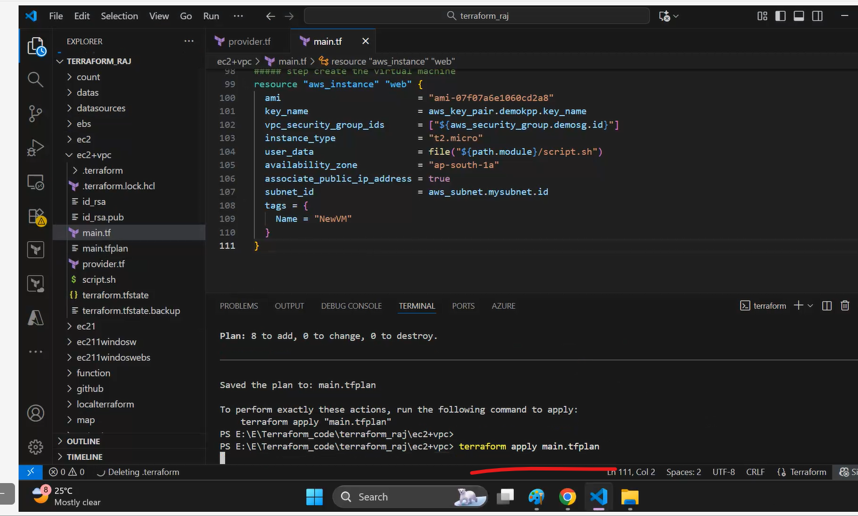

EC2, VPC creation through terraform and attaching EBS using terraform code…

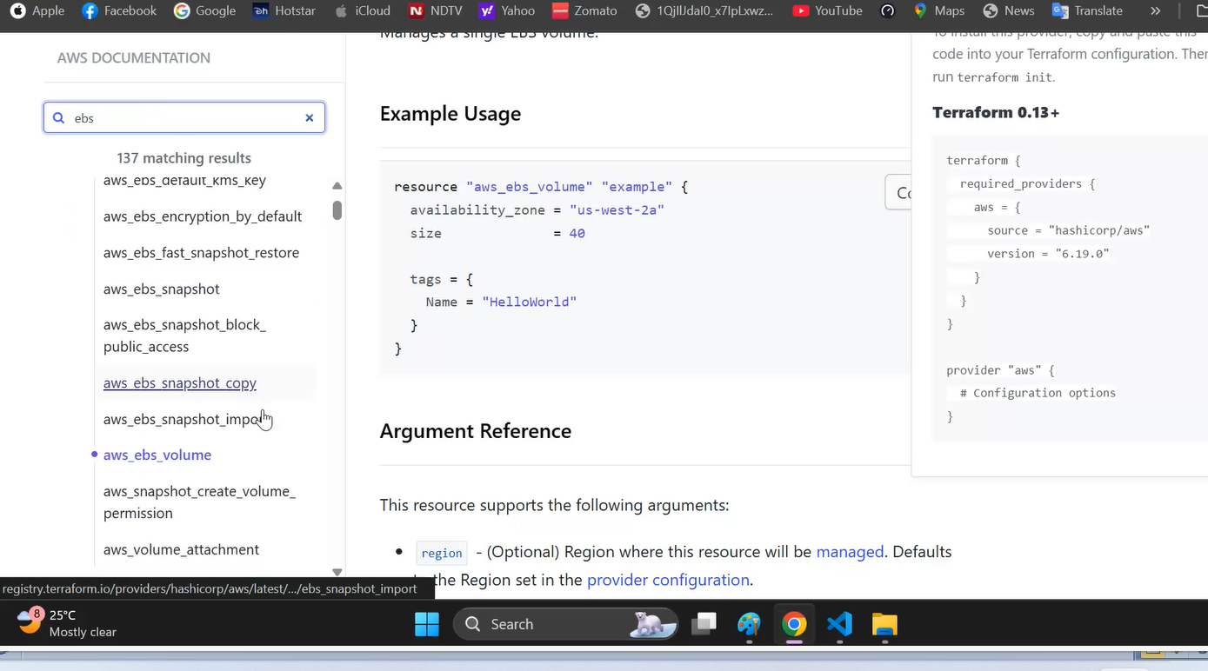

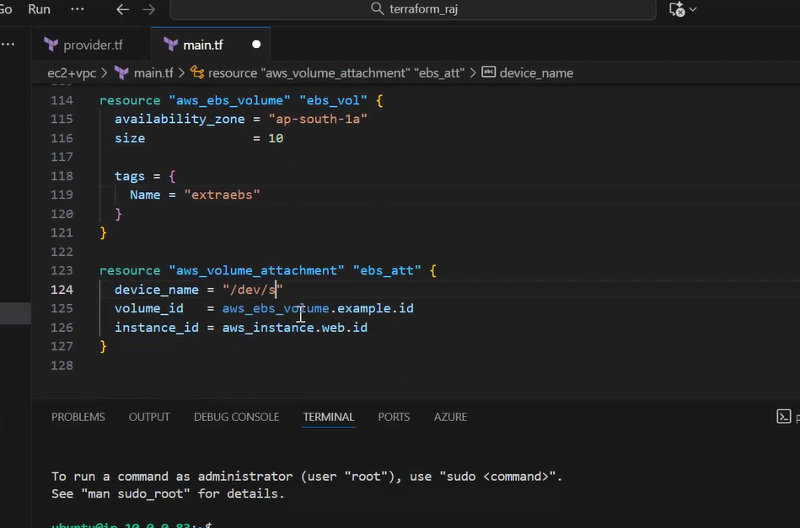

Added EBS block and association block

In prod….we cannot destroy…so we just do terraform plan and then do terraform apply

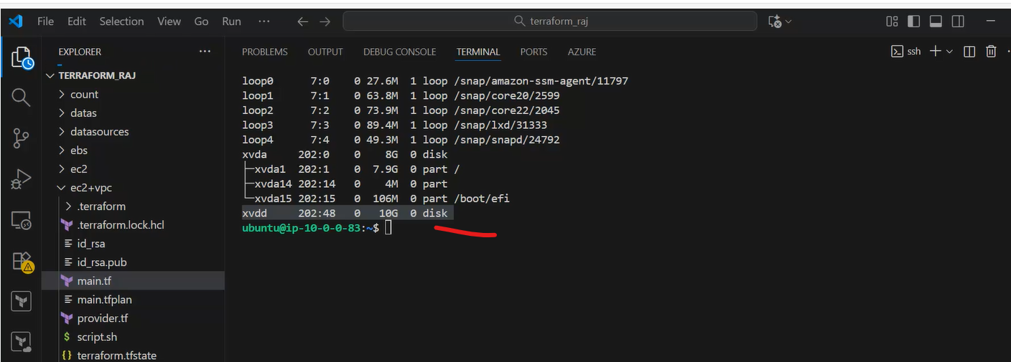

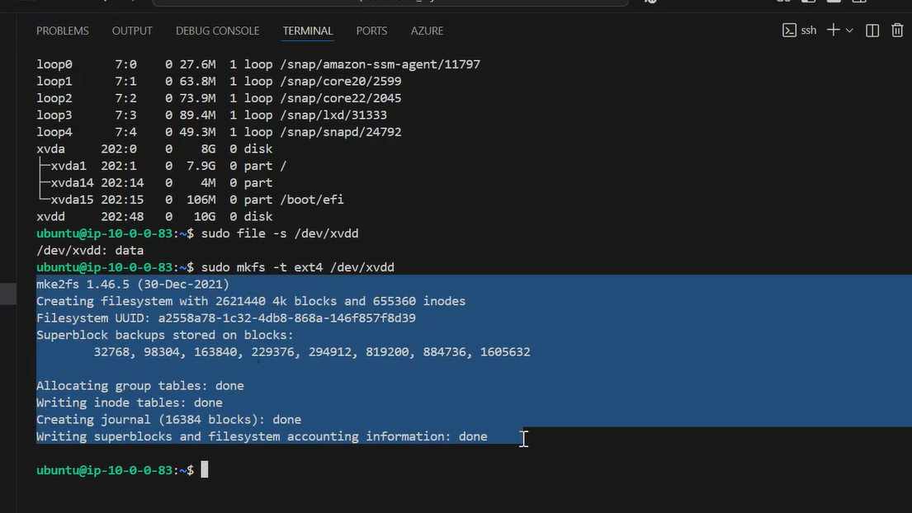

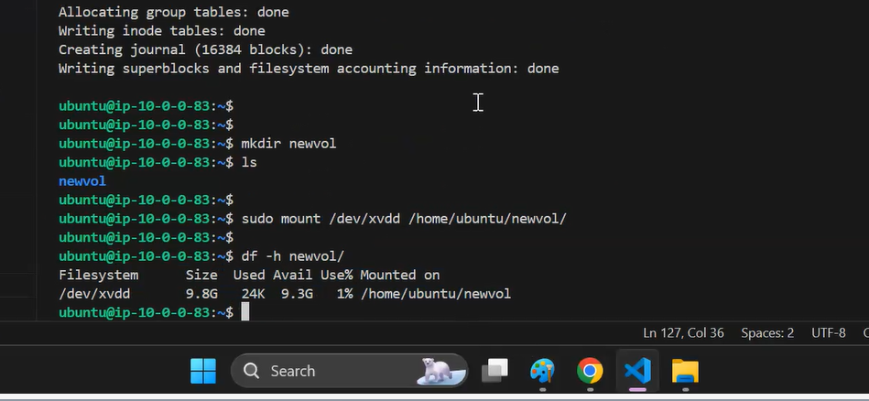

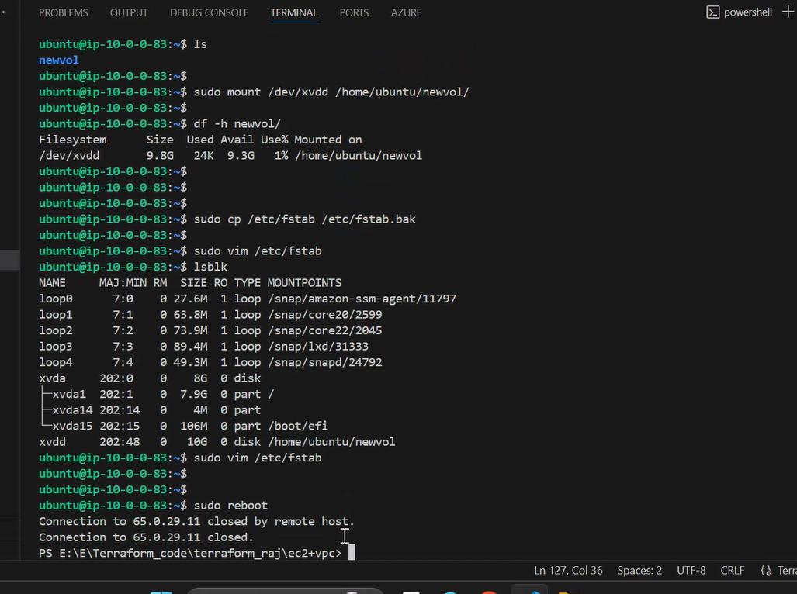

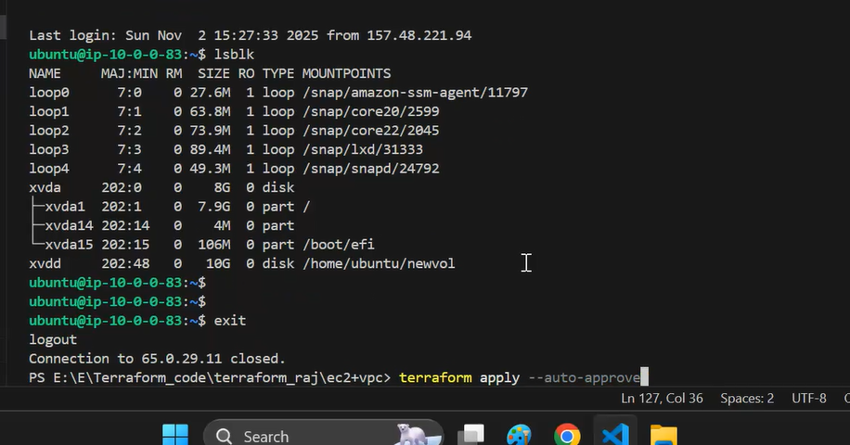

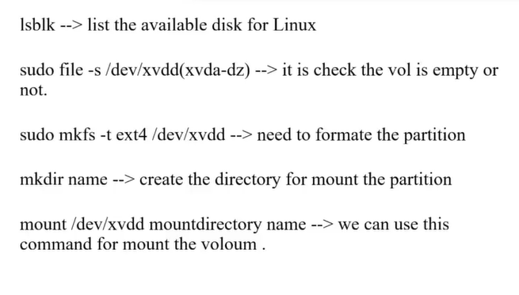

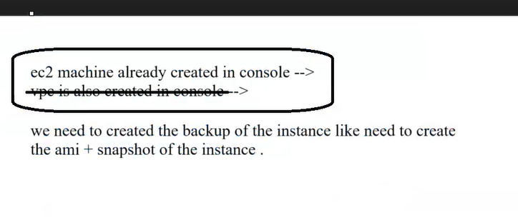

He is using default vpc so no extra charges….

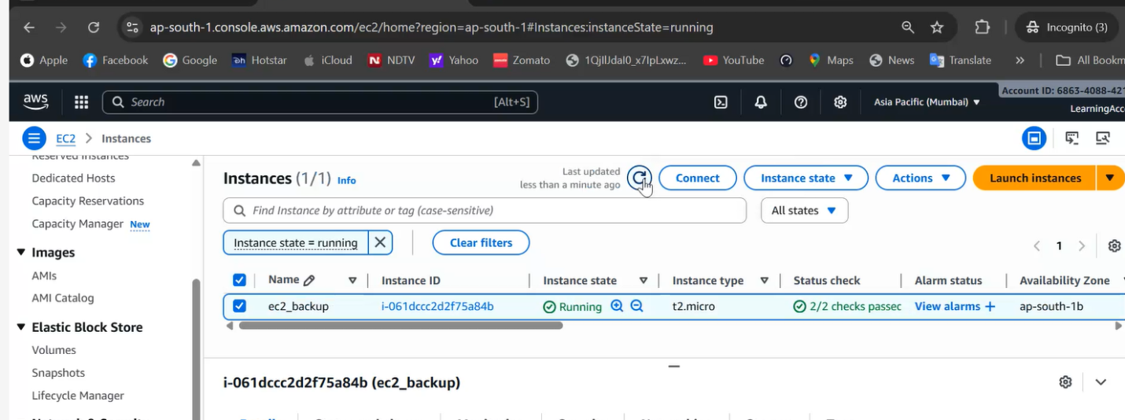

He connected to the VM…

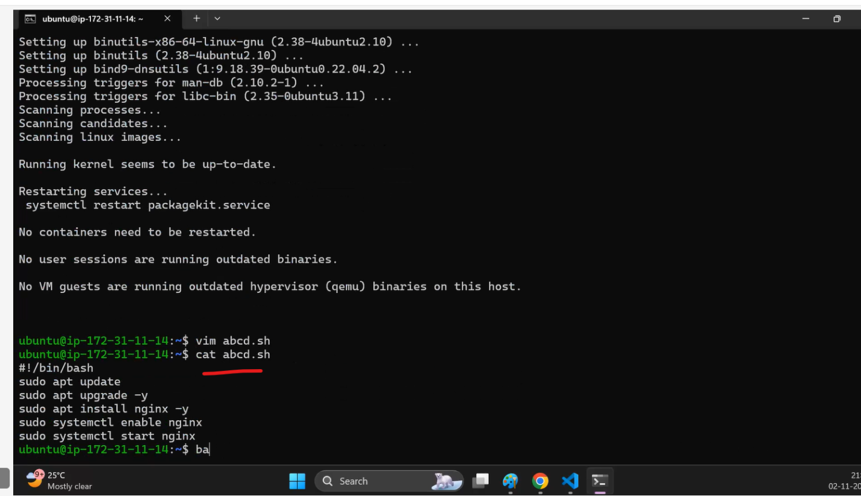

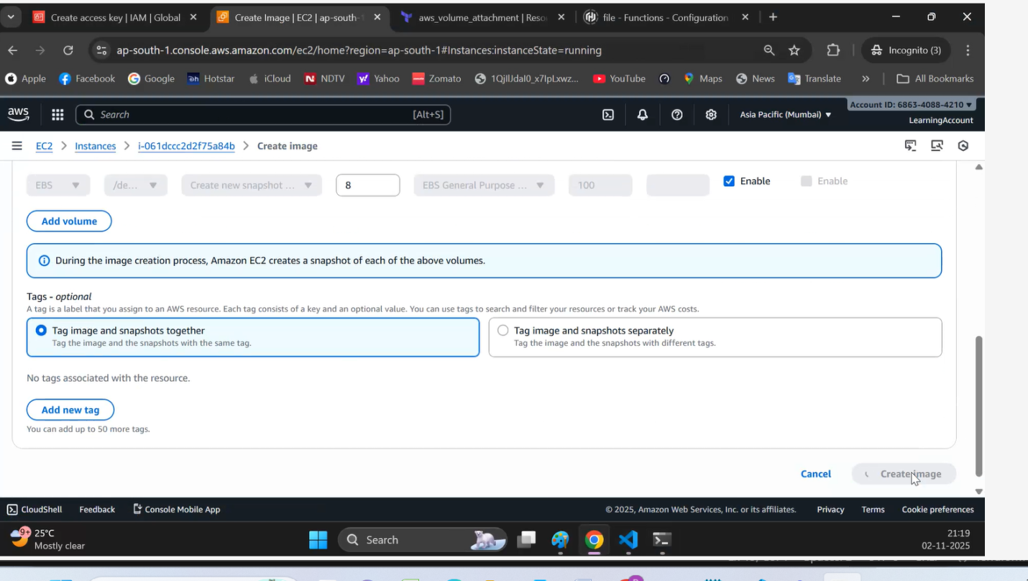

When creating Image…it is creating backup {AMI}….also snapshots

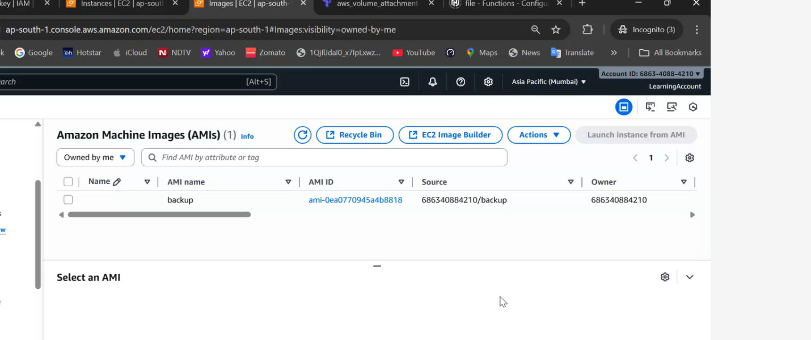  
he deleted back up and snapshot

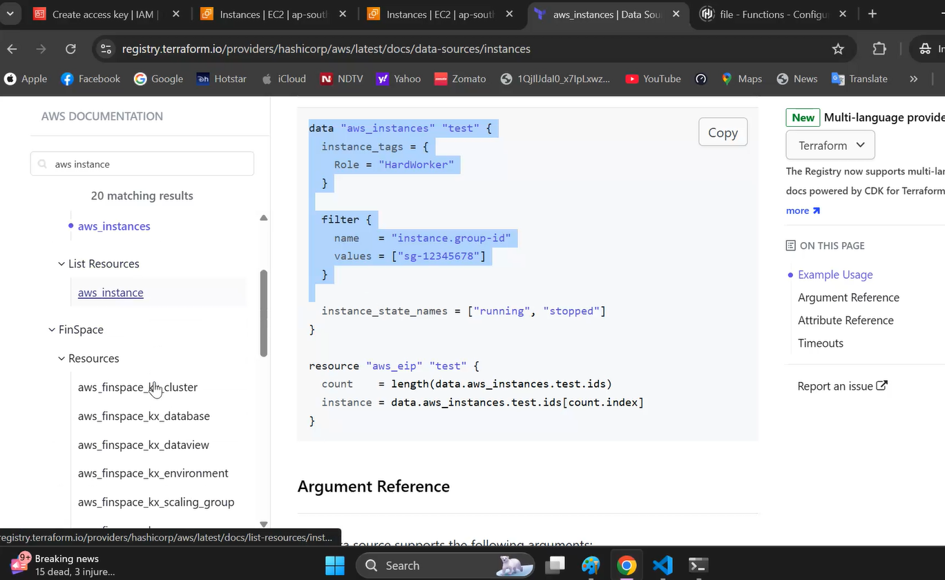

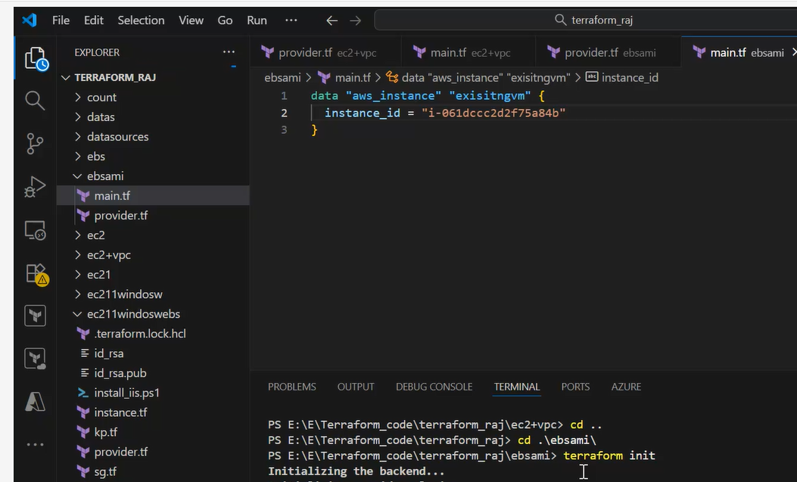

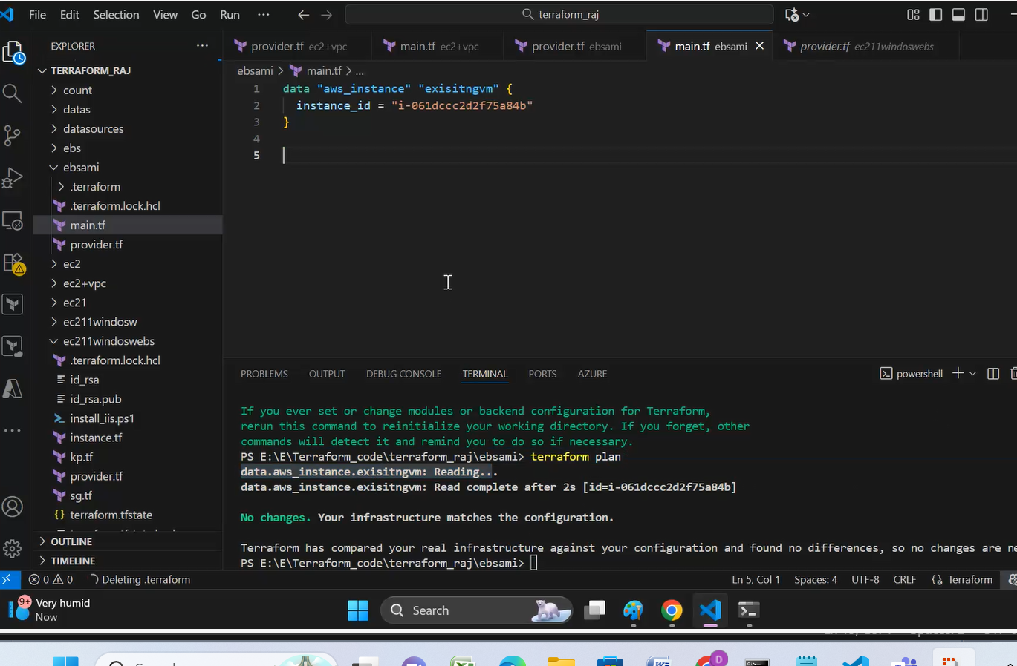

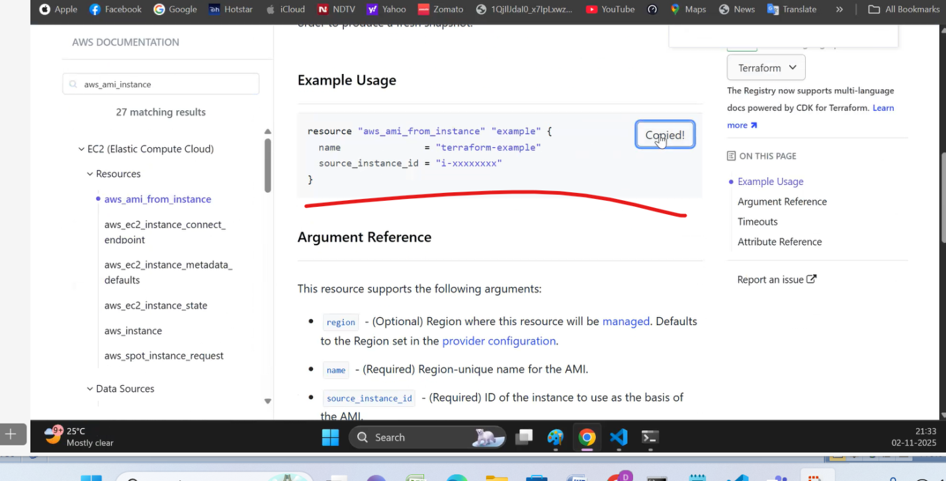

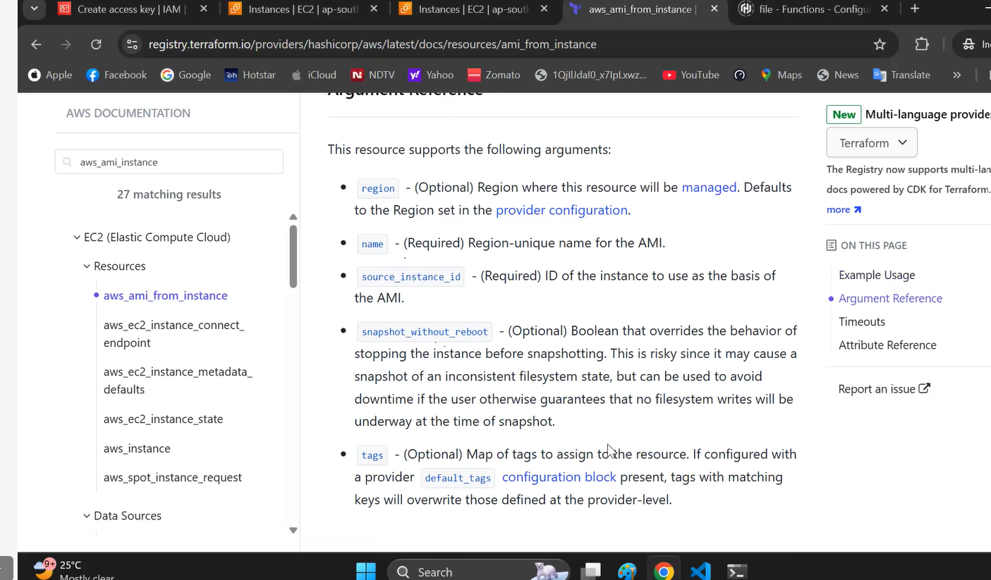

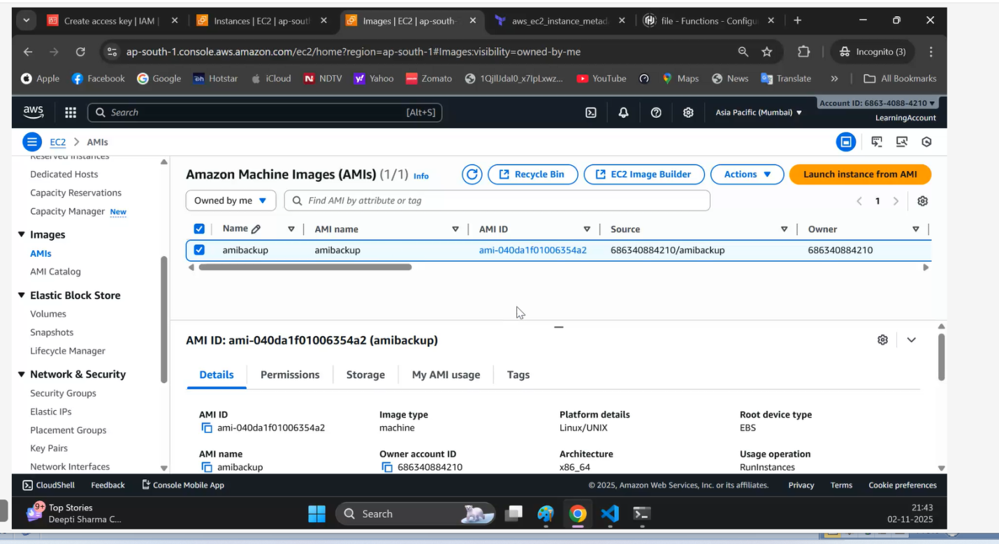

We can create a new VM using the backup….

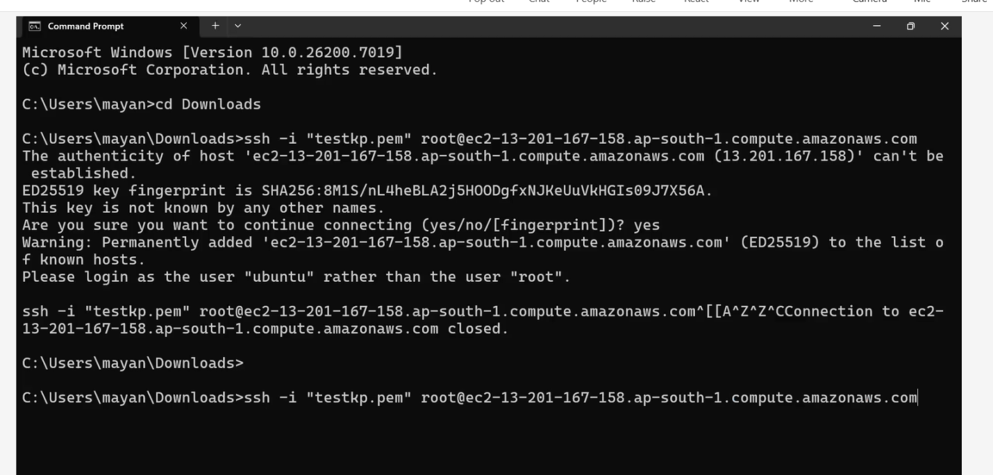

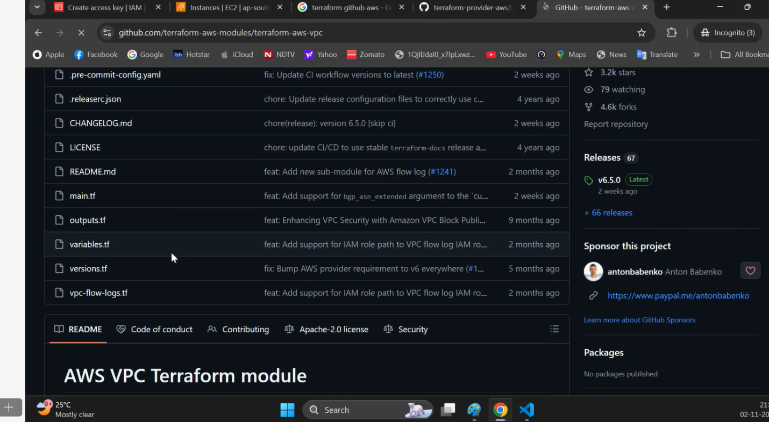

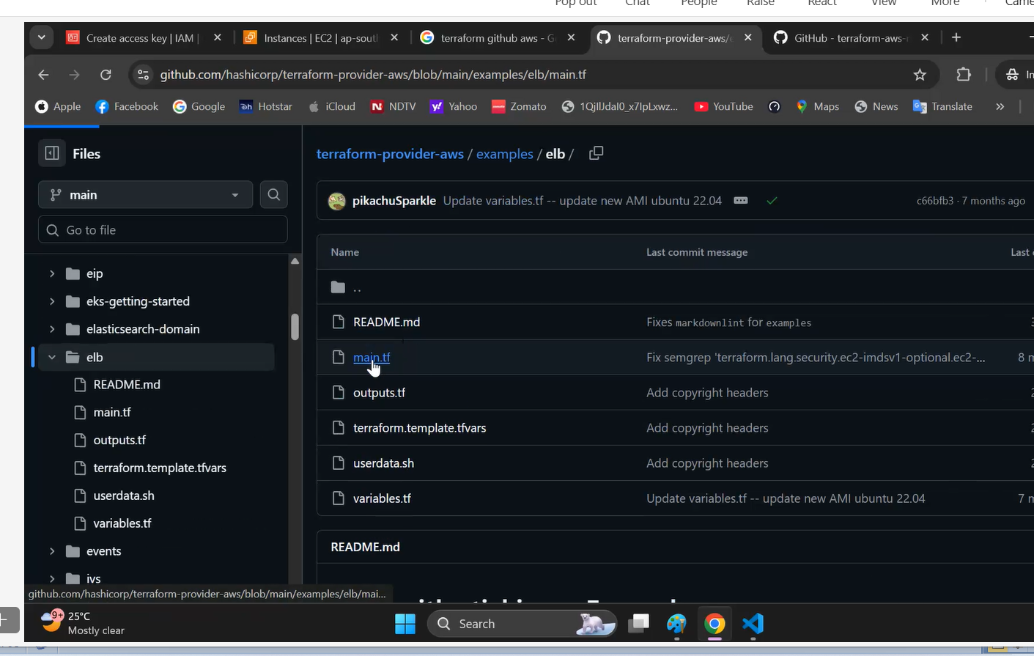

raj (Guest) no longer has access to the chat.

data "aws_instance" "exisitngvm" {

  instance_id = "i-061dccc2d2f75a84b"

}

resource "aws_ami_from_instance" "amivm" {

  name               = "amibackup"

  source_instance_id = data.aws_instance.exisitngvm.id

  description        = "creation of backup using the exisitng image"

  tags = {

    Name = "amibackup"

  }

}

##### step create the virtual machine

resource "aws_instance" "web" {

  ami                         = "ami-0432b8889b74a73e6"

  key_name                    = aws_key_pair.demokpp.key_name

  vpc_security_group_ids      = ["${aws_security_group.demosg.id}"]

  instance_type               = "t2.micro"

  associate_public_ip_address = true

  ####  user_data                   = file("${path.module}/install_iis.ps1")

  user_data = <<-EOF

              <powershell>

              Install-WindowsFeature -Name Web-Server -IncludeManagementTools

              </powershell>

              EOF

  tags = {

    Name = "NewVM"

  }

}

resource "aws_ebs_volume" "ebsvol" {

  availability_zone = aws_instance.web.availability_zone

  size              = 20

  type              = "gp3"

  tags = {

    Name = "extra_vol"

  }

}

resource "aws_volume_attachment" "ebs_att" {

  device_name  = "/dev/sdc"

  volume_id    = aws_ebs_volume.ebsvol.id

  instance_id  = aws_instance.web.id

  force_detach = true

}

 **********************

data "aws_instance" "exisitngvm" {

  instance_id = "i-061dccc2d2f75a84b"

}

resource "aws_ami_from_instance" "amivm" {

  name               = "amibackup"

  source_instance_id = data.aws_instance.exisitngvm.id

  description        = "creation of backup using the exisitng image"

  tags = {

    Name = "amibackup"

  }

}

##### step create the virtual machine

resource "aws_instance" "web" {

  ami                         = "ami-0432b8889b74a73e6"

  key_name                    = aws_key_pair.demokpp.key_name

  vpc_security_group_ids      = ["${aws_security_group.demosg.id}"]

  instance_type               = "t2.micro"

  associate_public_ip_address = true

  ####  user_data                   = file("${path.module}/install_iis.ps1")

  user_data = <<-EOF

              <powershell>

              Install-WindowsFeature -Name Web-Server -IncludeManagementTools

              </powershell>

              EOF

  tags = {

    Name = "NewVM"

  }

}

resource "aws_ebs_volume" "ebsvol" {

  availability_zone = aws_instance.web.availability_zone

  size              = 20

  type              = "gp3"

  tags = {

    Name = "extra_vol"

  }

}

resource "aws_volume_attachment" "ebs_att" {

  device_name  = "/dev/sdc"

  volume_id    = aws_ebs_volume.ebsvol.id

  instance_id  = aws_instance.web.id

  force_detach = true

}

resource "aws_ebs_volume" "example" {

  availability_zone = "ap-south-1a"

  size              = 40

  type              = "gp3"

  tags = {

    Name = "extra_vol"

  }

}

##### step create the virtual machine

resource "aws_instance" "web" {

  ami                         = "ami-0432b8889b74a73e6"

  key_name                    = aws_key_pair.demokpp.key_name

  vpc_security_group_ids      = ["${aws_security_group.demosg.id}"]

  instance_type               = "t2.micro"

  associate_public_ip_address = true

  ####  user_data                   = file("${path.module}/install_iis.ps1")

  user_data = <<-EOF

              <powershell>

              Install-WindowsFeature -Name Web-Server -IncludeManagementTools

              </powershell>

              EOF

  tags = {

    Name = "NewVM"

  }

}

resource "aws_ebs_volume" "ebsvol" {

  availability_zone = aws_instance.web.availability_zone

  size              = 20

  type              = "gp3"

  tags = {

    Name = "extra_vol"

  }

}

resource "aws_volume_attachment" "ebs_att" {

  device_name  = "/dev/sdc"

  volume_id    = aws_ebs_volume.ebsvol.id

  instance_id  = aws_instance.web.id

  force_detach = true

}

### create the vpc

resource "aws_vpc" "myvpc" {

  cidr_block = "10.0.0.0/16"

  tags = {

    Name = "myvpc"

  }

}

### creation of subnet

resource "aws_subnet" "mysubnet" {

  vpc_id            = aws_vpc.myvpc.id

  cidr_block        = "10.0.0.0/24"

  availability_zone = "ap-south-1a"

  tags = {

    Name = "Main"

  }

}

#### creation of ig

resource "aws_internet_gateway" "myig" {

  vpc_id = aws_vpc.myvpc.id

  tags = {

    Name = "MyIg"

  }

}

### creation of route table

resource "aws_route_table" "myrt" {

  vpc_id = aws_vpc.myvpc.id

  route {

    cidr_block = "0.0.0.0/0"

    gateway_id = aws_internet_gateway.myig.id

  }

  route {

    ipv6_cidr_block = "::/0"

    gateway_id      = aws_internet_gateway.myig.id

  }

  tags = {

    Name = "MYRT"

  }

}

### subnet assoication

resource "aws_route_table_association" "a" {

  subnet_id      = aws_subnet.mysubnet.id

  route_table_id = aws_route_table.myrt.id

}

#### step create the key pair

resource "aws_key_pair" "demokpp" {

  key_name   = "dempkpp"

  public_key = file("${path.module}/id_rsa.pub")

}

#### step create the security group

resource "aws_security_group" "demosg" {

  vpc_id      = aws_vpc.myvpc.id

  name        = "demosg"

  description = "provide the sg"

  ingress {

    from_port   = "22"

    to_port     = "22"

    description = "port 22 enable"

    protocol    = "tcp"

    cidr_blocks = ["0.0.0.0/0"]

  }

  ingress {

    from_port   = "80"

    to_port     = "80"

    description = "port 22 enable"

    protocol    = "tcp"

    cidr_blocks = ["0.0.0.0/0"]

  }

  ingress {

    from_port   = "3389"

    to_port     = "3389"

    description = "port 22 enable"

    protocol    = "tcp"

    cidr_blocks = ["0.0.0.0/0"]

  }

  egress {

    from_port   = "0"

    to_port     = "0"

    description = "port all enable"

    protocol    = "-1"

    cidr_blocks = ["0.0.0.0/0"]

  }

}

##### step create the virtual machine

resource "aws_instance" "web" {

  ami                         = "ami-07f07a6e1060cd2a8"

  key_name                    = aws_key_pair.demokpp.key_name

  vpc_security_group_ids      = ["${aws_security_group.demosg.id}"]

  instance_type               = "t2.micro"

  user_data                   = file("${path.module}/script.sh")

  availability_zone           = "ap-south-1a"

  associate_public_ip_address = true

  subnet_id                   = aws_subnet.mysubnet.id

  tags = {

    Name = "NewVM"

  }

}

resource "aws_ebs_volume" "ebs_vol" {

  availability_zone = "ap-south-1a"

  size              = 10

  type              = "gp3"

  tags = {

    Name = "extraebs"

  }

}

resource "aws_volume_attachment" "ebs_att" {

  device_name = "/dev/sdd"

  volume_id   = aws_ebs_volume.ebs_vol.id

  instance_id = aws_instance.web.id

}